# Importing GIS Network Data from VISUM, Cube, TransCAD Files with Examples

*Version 2: Prepared by Dana Alsader (dana.alsader@asu.edu)*

*Last Revised: April, 2016*

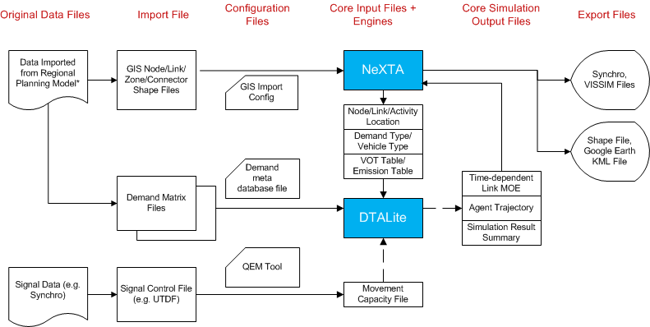

FWork Flow Chart for Importing, Analyzing and Exporting Data

## Reference: Data Flow for Performing Dynamic Traffic Analysis

**Goal:**

The following sections describe techniques and processes for importing and exporting network data using NeXTA’s new network conversion tools. Specifically, these tools provide the capabilities of preparing and importing shape and demand files from VISUM, Cube, TransCAD and other shape files. To demonstrate this functionality, and assist the user throughout the conversion process,

**Examples:**

1. [West Valley City, UT 3500 S sub-network (VISUM)](https://drive.google.com/?tab=wo&authuser=0#folders/0Bw8gtHCvOm7WUXVWS3BWalRCX28)
2. [South Jordan, UT sub-network (Cube)](https://drive.google.com/?tab=wo&authuser=0#folders/0Bw8gtHCvOm7WcVBXRmltZGhJcVk)

**\*NeXTA:** The NeXTA used in this assignment is NeXTA GIS Tool

**Content:**

Lesson 1.1: Importing GIS Network Data from VISUM and Cube with Examples

Introduction

Methodology for Importing VISUM Networks

Example 1: West Valley City Sub-Network

Step 1: Export network and demand data from VISUM

1) Load the network in VISUM

2) Export network as shapefiles

3) Export demand tables/matrices

Step 2: Update input link type and input node data

Step 3: Import network from VISUM

1) Prepare the configuration file for conversion

2) Use NeXTA’s import network tool to convert the network

3) Save the new network as a new project file

Methodology for Importing Cube Networks

Example 2: South Jordan Sub-Network

Step 1: Export network and demand data from Cube

Step 2: Import network from Cube

1) Prepare the configuration file for conversion

2) Use NeXTA’s import network tool to convert the network

Import demand data from regional travel demand model (VISUM)

## 

## Introduction

NeXTA’s network conversion tool specifically imports network data from shapefiles, which are geospatial vector data files used with Geographic Information System (GIS) software and commonly supported by many transportation modeling software packages. Shapefiles contain spatial information about points, lines, and polygons in the transportation network, with separate files for different shapes. Road networks are represented as a graph of links (lines) and nodes (points), where links may represent road segments or transit lines and nodes may represent intersections or connections between individual links, and trips are often made between zones (polygons) on the network.

Network attribute data is stored in database (DBF) files for each shapefile, which must be read by NeXTA during the conversion process. Network data formatting is very flexible between network modeling software packages, with many applications allowing users to define custom formats and data fields for use within a software package. To support these applications, NeXTA uses a configuration CSV file for importing GIS settings, to identify and connect the fields in the input DBF files to their corresponding fields in the NeXTA/DTALite data format (import_GIS_settings.csv).

The user must be very careful when preparing the input data for conversion in NeXTA, specifically when selecting the map projection used to create the input shapefiles. A map projection identifies how 3-dimensional data is displayed on a 2-dimensional surface, and different shapefiles may have different map projections. The same shapefile, displayed with different map projections, can appear in completely separate locations, or show slightly different spatial alignments. To resolve this issue, it is important that the user makes sure that all input shapefiles have the same map projection before using the conversion tool. NeXTA currently supports arbitrary coordinate system but have a preferred map projection – WGS84, the default projection for Google Earth and the KML data standard. Map projection data is stored in a projection (PRJ) file within the shapefile standard. Therefore, it is the user’s responsibility to make sure that shapefiles used for conversion in NeXTA all have WGS84 projection.

## Methodology for Importing VISUM Networks

The conversion tools offer the ability to convert networks for modeling at different spatial and temporal resolutions. However, this type of conversion often results in problems in network representation and data inconsistencies. The examples in this section follow a specific methodology for maintaining network and input data integrity between network models to support analysis at mesoscopic and microscopic modeling resolutions. This methodology is detailed below.

**Step 1:** Export network and demand data from VISUM

**Step 2:** Prepare input link type and input node and GIS importing setting data

**Step 3:** Import network into NeXTA

**Step 4:** Import demand data

**Step 5:** Run assignment with DTALite to equilibrium

**Step 6:** Export to Synchro/VISSIM for signal optimization and/or microscopic analysis

## 

## Example 1: [West Valley City Sub-Network](https://drive.google.com/?tab=wo&authuser=0#folders/0Bw8gtHCvOm7WUXVWS3BWalRCX28)

This example provides a step-by-step process to guide the user through converting the West Valley City sub-network for use in NeXTA/DTALite. This sub-network includes the busiest corridor of the 3500 South arterial in West Valley City, UT. The sub-network was obtained from the regional planning model and customized in VISUM.

### Step 1: Export network and demand data from VISUM

The first step in the network conversion process is to create a set of shapefiles describing the network to be imported into NeXTA. This is normally accomplished using export functions in the software used to prepare the selected network, and can be divided into three internal steps:

1. Load the network in originating software application
2. Export network as shapefiles
3. Export demand tables/matrices

#### 1) Load the network in VISUM

In this example, the West Valley City sub-network was coded in VISUM and must be exported as a set of shapefiles. First, the network is loaded in VISUM.

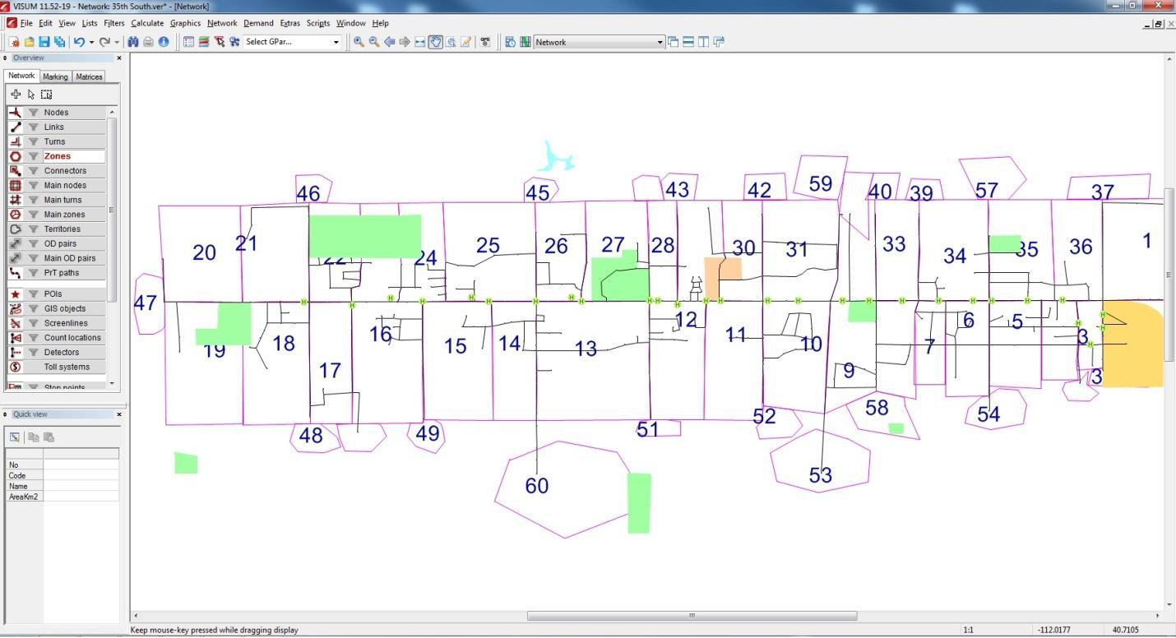

**Figure 1: West Valley City sub-network loaded in VISUM**

Once the network is loaded in VISUM, it is recommended to check the map projections system and set it to WGS84 if some other system is used. In VISUM, this can be done by setting Network Parameters. In the Menu toolbar, go to Network -> Network Parameters… , select the Scale tab and check the Spatial reference system. Make sure that the From file option is checked, and that the reference system is set to GCS_WGS_1984. This procedure is shown in Figure 2. If the projection system is not changed in this step, the user must manipulate the shapefiles exported from VISUM in third-party software.

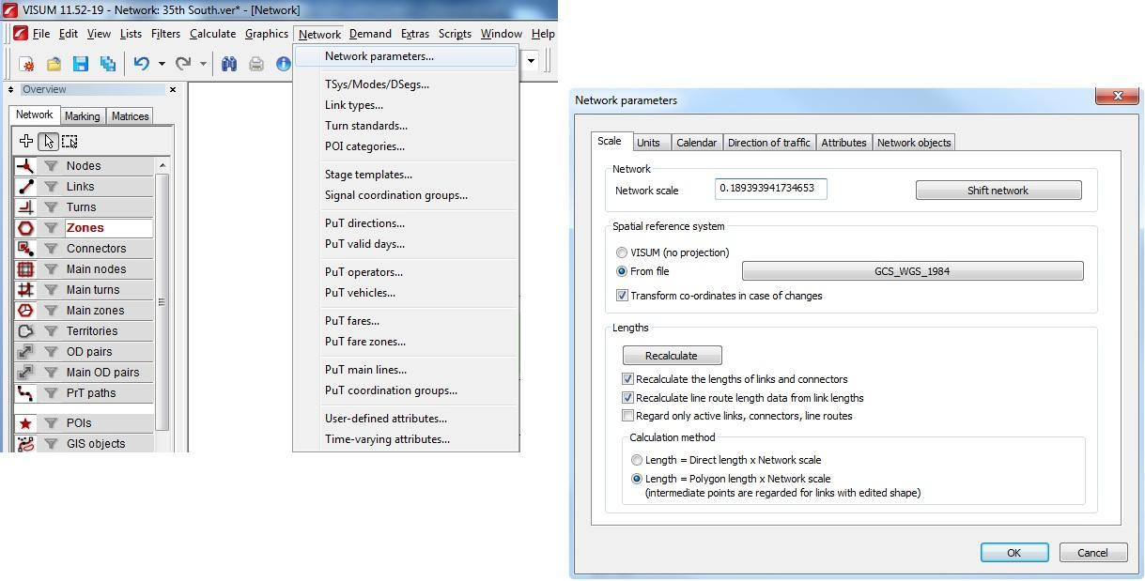

**Figure 2: Setting map projection system in VISUM**

#### 2) Export network as shapefiles

By using VISUM’s export function (File -> Export -> Shapefile), the network is split into its components, and saved as multiple separate shapefiles. First the user selects the destination folder for the network, gives the base name of the exported files under the File name (e.g. 35_S_export), and VISUM automatically adds suffix names for each layer. After pressing the Save button, VISUM opens another window where the user can choose which layers to export. The user should at least select the node, link, zone, zone centroid, and connector layers to ensure that the conversion process can successfully create a new network. While it is recommended that the user changes the export options to save the links as directed links to minimize any potential problems in the conversion process, the appropriate setting will depend on the network coding format. NeXTA can import networks with both directed and non-directed links. The user can also identify which columns will be exported with the shapefiles, which may be helpful to minimize confusion when working with shapefiles with large database files, or when working with multiple scenarios in the same network files. VISUM will export the shapefiles in the previously defined projection system. Once finished selecting export options, select “OK” at the bottom of the dialog box. This procedure is given in Figure 3.

#### 3) Export demand tables/matrices

Click on the Matrices tab in the Overview toolbar to display the demand matrices. The zone matrices are compatible with the demand definition in NeXTA, so they are the main focus of this effort. Right click on the desired matrix, select Save to File…, navigate to the destination folder, give the name to the matrix, select Save, and in the next window select Format O from the Format dropdown list. . Format O is a common 3-column format that can be easily read by NeXTA. NeXTA also supports the standard VISUM “Format V” demand matrix format, which takes the form of a table with size Origin x Destination. The user should reference the VISUM User Manual for more information regarding different demand matrix formatting types. This matrix exporting procedure is shown in Figure 4.

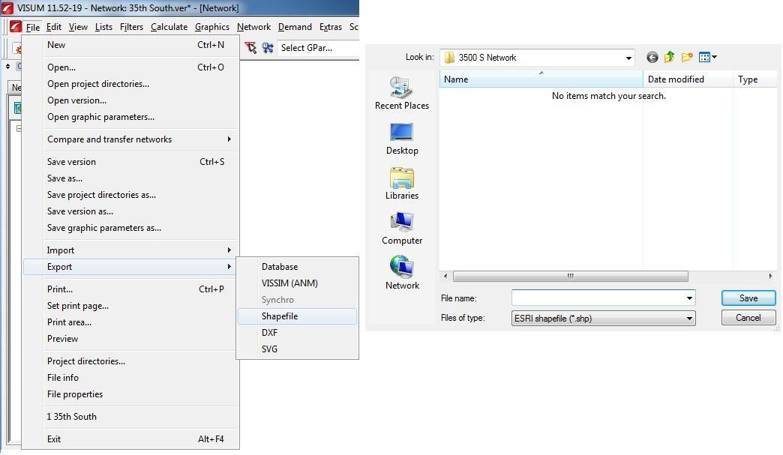

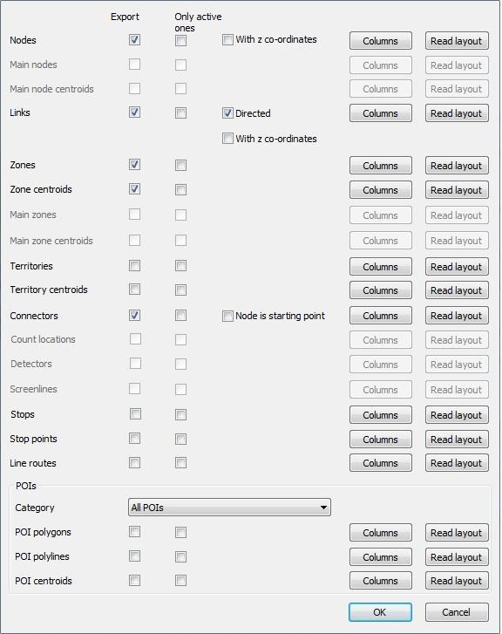

**Figure 3: Exporting shapefiles from VISUM**

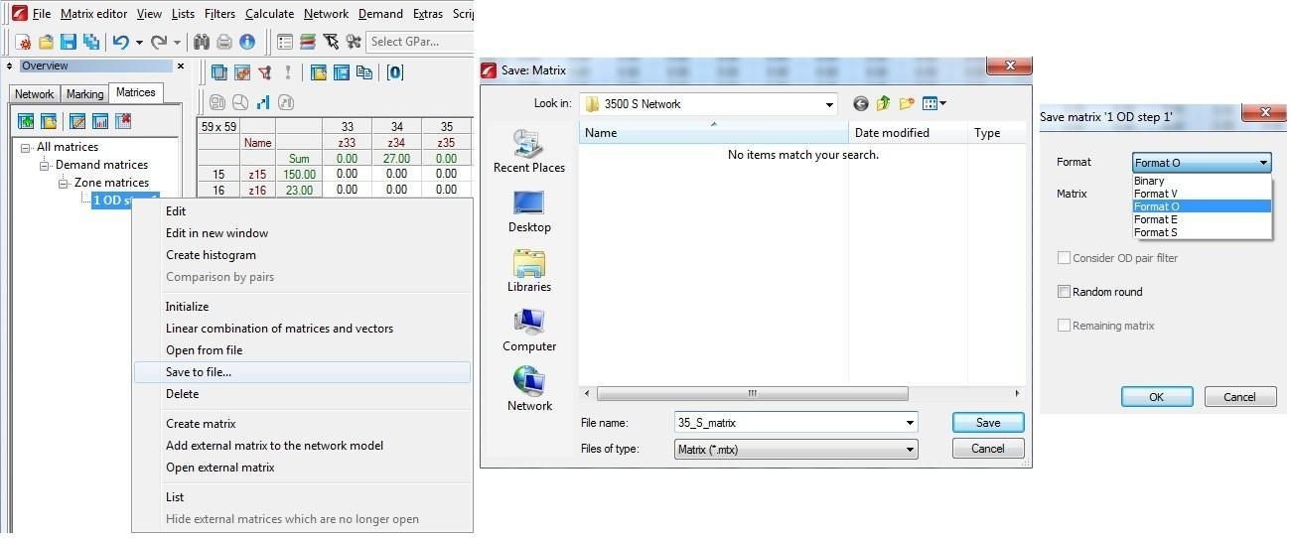

**Figure 4: Exporting matrices from VISUM**

The shapefiles and the matrix are now placed in the destination folder. If you open the folder, you should see the following files:

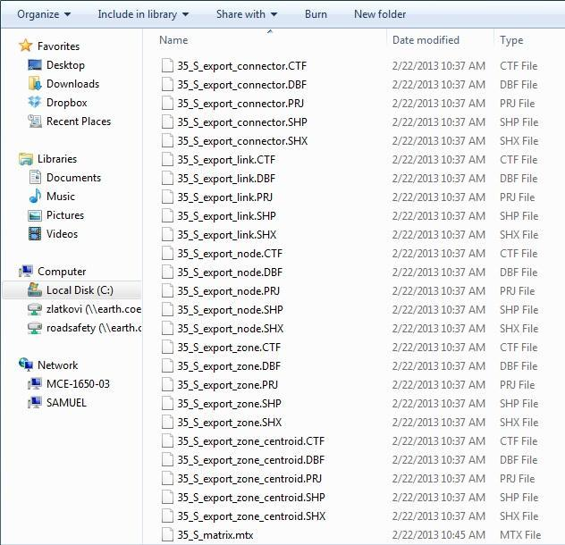

**Figure 5: Exported files in destination folder**

### Step 2: Update input link type and input node data

The link type list in VISUM shows all link types used in the current network, as shown in Figure 6. It can be seen that there are a lot more link types than the default NeXTA values given in the input_link_type.csv file. For that reason, this CSV file needs to be updated with the current link types.

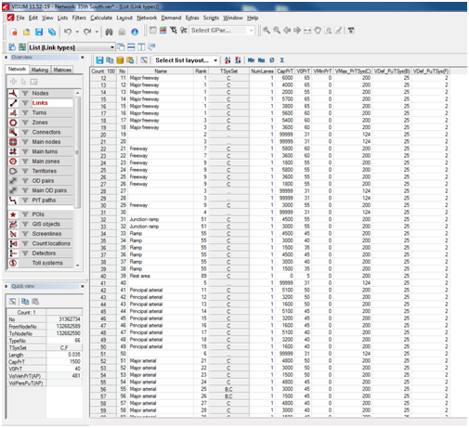

**Figure 6: Link types in VISUM for current network**

For the given example of the West Valley City VISUM network, the updated link type table should look like as follows:

|  |  |  |  |  |  |
| --- | --- | --- | --- | --- | --- |
| link_type | link_type_name | type _code | default_lane _capacity | default_ speed_limit | default_number _of_lanes |
| 11 | Freeway | f | 1800 | 65 | 3 |
| 12 | Freeway | f | 1800 | 65 | 3 |
| 13 | Freeway | f | 1800 | 65 | 3 |
| 14 | Freeway | f | 1800 | 65 | 3 |
| 15 | Freeway | f | 1800 | 65 | 3 |
| 16 | Freeway | f | 1800 | 65 | 3 |
| 17 | Freeway | f | 1800 | 65 | 3 |
| 18 | Freeway | f | 1800 | 65 | 3 |
| 21 | Freeway | f | 1800 | 65 | 3 |
| 22 | Freeway | f | 1800 | 65 | 3 |
| 23 | Freeway | f | 1800 | 65 | 3 |
| 24 | Freeway | f | 1800 | 65 | 3 |
| 25 | Freeway | f | 1800 | 65 | 3 |
| 26 | Freeway | f | 1800 | 65 | 3 |
| 29 | Freeway | f | 1800 | 65 | 3 |
| 2 | Highway/Expressway | h | 1450 | 50 | 3 |
| 41 | Principal arterial | a | 1000 | 40 | 3 |
| 42 | Principal arterial | a | 1000 | 40 | 3 |
| 43 | Principal arterial | a | 1000 | 40 | 3 |
| 44 | Principal arterial | a | 1000 | 40 | 3 |
| 45 | Principal arterial | a | 1000 | 40 | 3 |
| 46 | Principal arterial | a | 1000 | 40 | 3 |
| 47 | Principal arterial | a | 1000 | 40 | 3 |
| 48 | Principal arterial | a | 1000 | 40 | 3 |
| 49 | Principal arterial | a | 1000 | 40 | 3 |
| 51 | Major arterial | a | 900 | 35 | 3 |
| 52 | Major arterial | a | 900 | 35 | 3 |
| 53 | Major arterial | a | 900 | 35 | 3 |
| 54 | Major arterial | a | 900 | 35 | 3 |
| 55 | Major arterial | a | 900 | 35 | 3 |
| 56 | Major arterial | a | 900 | 35 | 3 |
| 57 | Major arterial | a | 900 | 35 | 3 |
| 58 | Major arterial | a | 900 | 35 | 3 |
| 59 | Major arterial | a | 900 | 35 | 3 |
| 61 | Minor arterial | a | 850 | 30 | 2 |
| 62 | Minor arterial | a | 850 | 30 | 2 |
| 63 | Minor arterial | a | 850 | 30 | 2 |
| 64 | Minor arterial | a | 850 | 30 | 2 |
| 65 | Minor arterial | a | 850 | 30 | 2 |
| 66 | Minor arterial | a | 850 | 30 | 2 |
| 67 | Minor arterial | a | 850 | 30 | 2 |
| 68 | Minor arterial | a | 850 | 30 | 2 |
| 69 | Minor arterial | a | 850 | 30 | 2 |
| 71 | Collector | a | 650 | 25 | 1 |
| 72 | Collector | a | 650 | 25 | 1 |
| 73 | Collector | a | 650 | 25 | 1 |
| 74 | Collector | a | 650 | 25 | 1 |
| 75 | Collector | a | 650 | 25 | 1 |
| 76 | Collector | a | 650 | 25 | 1 |
| 77 | Collector | a | 650 | 25 | 1 |
| 78 | Collector | a | 650 | 25 | 1 |
| 79 | Collector | a | 650 | 25 | 1 |
| 81 | Local | a | 600 | 20 | 1 |
| 82 | Local | a | 600 | 20 | 1 |
| 85 | Local | a | 600 | 20 | 1 |
| 86 | Local | a | 600 | 20 | 1 |
| 99 | Local | a | 600 | 20 | 1 |
| 8 | Frontage road | a | 1000 | 45 | 2 |
| 31 | Ramp | r | 1300 | 30 | 2 |
| 32 | Ramp | r | 1300 | 30 | 2 |
| 33 | Ramp | r | 1300 | 30 | 2 |
| 34 | Ramp | r | 1300 | 30 | 2 |
| 35 | Ramp | r | 1300 | 30 | 2 |
| 36 | Ramp | r | 1300 | 30 | 2 |
| 37 | Ramp | r | 1300 | 30 | 2 |
| 38 | Ramp | r | 1300 | 30 | 2 |
| 10 | Zonal connector | c | 2000 | 100 | 2 |
| 100 | Transit link | t | 1000 | 40 | 1 |
| 200 | Walking link | w | 1000 | 5 | 1 |

The input node table should also be updated with the current control type, especially for signalized intersections. For a given VISUM network, this can be done by matching the node number in VISUM and the input_node.csv file, and setting the correct control type in the CSV file. The easiest way is to open the node list in VISUM, and sort the nodes by control type. Figure 7 shows an example of the sorted nodes in VISUM for the given network. There are 13 signalized nodes, and for other the control type is unknown.

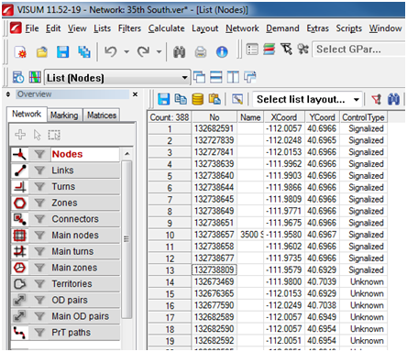

**Figure 7: Node control types in VISUM for current network**

When the project network is opened in NeXTA, it should reflect the new changes made in the input CSV files. The user is encouraged to compare the network between NeXTA and VISUM to make sure the network is coded correctly.

### Step 3: Import network from VISUM

The third step in the network conversion process is to use NeXTA’s network import tool to convert the shapefiles (created in the previous step) into a network which can be used with NeXTA and DTALite. This process reads the spatial data stored in each specified shapefile, along with the corresponding data stored in the database (DBF) file, to create the input CSV files used by NeXTA and DTALite. In order to interpret the database (DBF) files for conversion, a GIS configuration CSV file is used to map field names between the shapefiles and the standard data format used by NeXTA (import_GIS_settings.csv).

The network import process is divided into three internal steps:

1. Prepare the configuration file for conversion
2. Use NeXTA’s import network tool to convert the network
3. Save the new network as a new project file

#### 1) Prepare the configuration file for conversion

First, create a configuration file in the folder containing the exported shapefiles (import_GIS_settings.csv). This file is located in the NeXTA’s folder, under importing_sample_data_sets\GIS_data_set. The user should copy this CSV file to the destination folder, and make the changes needed for successful input process.

The configuration file consists of several sections, as defined in Column A. There are several sections of information in column “value” to be prepared by users, namely, file, configuration, node, link, zone, and optional centroid and connector layers.

The “key” settings given in Column B are used by NeXTA to successfully match and convert the shapefiles from the DBF files.

“Value” in Column C is the matching name between NeXTA’s “key” values, and those given in the shapefiles. When used with VISUM, these values are read from the corresponding lists accesses in VISUM through Menu -> Lists, or the converted shapefiles can be opened in any GIS software and accessed through attribute tables. “Allowed_values” in Column D show which definitions are related to “value” for binary values (such as km vs. mile, lane vs. link, etc). Column E (“required_or_optional”) shows which values must be defined for a successful import.

**Remark: Although this configuration contains many data fields, users only need to prepare or change the data in column “value”.**

A sample file can be always found under Internal_release\importing_sample_data_sets\GIS_files\West_Jordan_from_CUB

The first section defines the shape file names for nodes, links, zones, centroids, and connectors. In this example, the file name table looks like this:

|  |  |  |  |  |
| --- | --- | --- | --- | --- |
| section | key | value | allowed_values | required |
| file_name | node | 35_S_export_node.shp |  | x |
| file_name | link | 35_S_export_link.shp |  | x |
| file_name | zone | 35_S_export_zone.shp |  |  |
| file_name | centroid | 35_S_export_zone_centroid.shp |  |  |
| file_name | connector | 35_S_export_connector.shp |  |  |

The reference file names should correspond to the layers exported from VISUM. In this case, the file names have the format '35_S_export_(layer).shp'. Node and link are the required layers for a successful GIS network import.

The next configuration section defines configuration settings to accommodate different network field and format coding conventions. These settings include the latitude/longitude coordinate system definition, length units, one way vs. two way links, and whether the capacity is given per lane, or per link. In the given example, the configuration settings are as follows:

|  |  |  |  |  |
| --- | --- | --- | --- | --- |
| section | key | value | allowed_values | required |
| configuration | with_decimal_long_lat | yes | yes;no |  |
| configuration | length_unit | mile | km;mile |  |
| configuration | number_of_lanes_oneway_vs_twoway | oneway | oneway;twoway |  |
| configuration | lane_capacity_vs_link_capacity | lane | lane;link |  |

|  |  |  |  |  |
| --- | --- | --- | --- | --- |
| configuration | direction_0_as_oneway_vs_twoway | oneway | oneway;twoway |  |
| configuration | node_number_threshold_as_centroid | 0 | default 0 |  |
| configuration | use_default_speed_limit_from_link_type | no | yes;no |  |
| configuration | use_default_lane_capacity_from_link_type | no | yes;no |  |
| configuration | use_default_number_of_lanes_from_link_type | no | yes;no |  |
| configuration | identify_signal_intersection | yes |  | yes;no |
| configuration | minimum_speed_limit_for_signals | 28 |  |  |
| configuration | maximum_speed_limit_for_signals | 60 |  |  |
| configuration | default_cycle_length_in_second | 110 |  |  |
| configuration | minimum_length_for_importing_links | 0.00001 |  |  |

The next section defines node attributes. The import values are node ID, node name, the zone (TAZ) to which a certain node belongs to, and node control type. In the given example, the node table is as follows:

|  |  |  |  |  |
| --- | --- | --- | --- | --- |
| section | key | value | allowed_values | required |
| node | node_id | NO |  |  |
| node | name | NAME |  |  |
| node | TAZ |  |  |  |
| node | control_type | CONTROLT~1 |  |  |

To see the correct definition node attributes, in VISUM go to Menu -> Lists -> Nodes and read the definitions from the corresponding columns. An example of the node list for this sub-network is given in Figure 6. For example, the node ID is the numerical value given in the column “No”. The node ID, TAZ, name and control type should correspond to the attributes defined in VISUM.

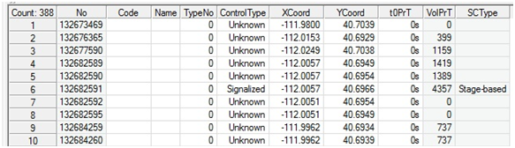

**Figure 8: Node list in VISUM**

The user needs to be careful with attribute names that have more than 10 characters (such as ControlType in this case). The exported SHP/DBF file will convert the file name to the 10-character length (Controlt~1). To see the correct attribute name definitions, the user can use any GIS software to open the corresponding shapefile and read the name from the attribute table. Figure 9 shows an example for the node layer attribute table accessed through Quantum GIS. Note the adjusted name for control type:

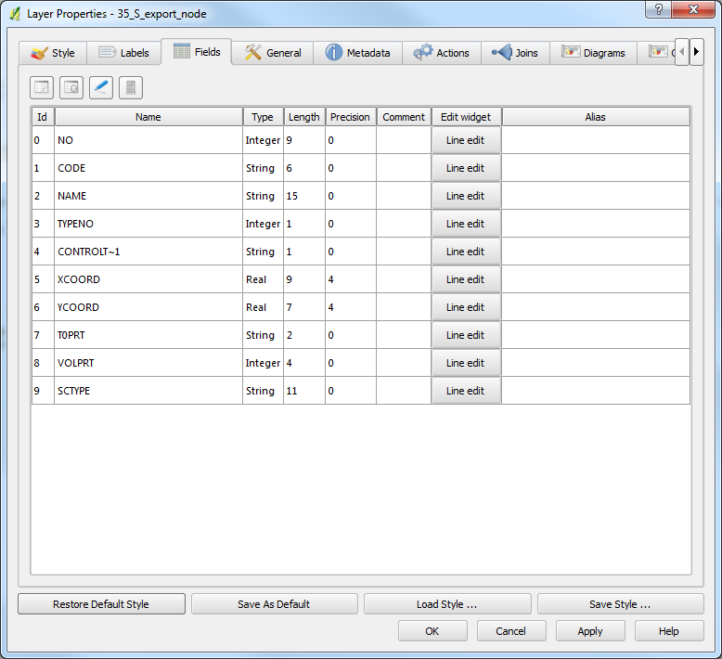

**Figure 9: Node list in Q GIS**

The second section defines the link shapefile attributes. In order to code the corresponding attributes correctly, the user needs to open the link list in VISUM (Menu -> Lists -> Links), or access the link shapefile through GIS software, and read the link attributes. The available link attributes are from and to node, name, link ID, link type, transportation modes that link is open for, direction definition, length, number of lanes, hourly capacity, speed limit, and number of lanes, capacity, speed limit and link type for reversible lanes, if links are defined as two way links. For this example, the link table is as follows:

|  |  |  |  |  |
| --- | --- | --- | --- | --- |
| section | key | value | allowed_values | required |
| link | from_node_id | FROMNODENO |  |  |
| link | to_node_id | TONODENO |  |  |
| link | name | NAME |  |  |
| link | link_id | NO |  |  |
| link | link_type | TYPENO |  |  |
| link | mode_code | TSYSSET |  |  |
| link | direction |  |  |  |
| link | length | LENGTH |  |  |
| link | number_of_lanes | NUMLANES |  |  |
| link | hourly_capacity | CAPPRT |  |  |
| link | speed_limit | V0PRT |  |  |
| link | r_number_of_lanes |  |  |  |
| link | r_hourly_capacity |  |  |  |
| link | r_speed_limit |  |  |  |
| link | r_link_type |  |  |  |

Note that there is a separate CSV file for link types (input_link_type.csv) that needs to be updated with the correct link types exported from VISUM.

The attributes can be read from the link list in VISUM or through GIS. Example for this network are given in Figures 10 and 11. The attributes denoted with r_ refer to the reverse links, if the oneway_vs_twoway is set to twoway.

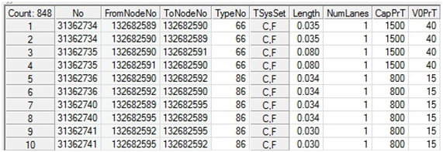

**Figure 10: Link list in VISUM**

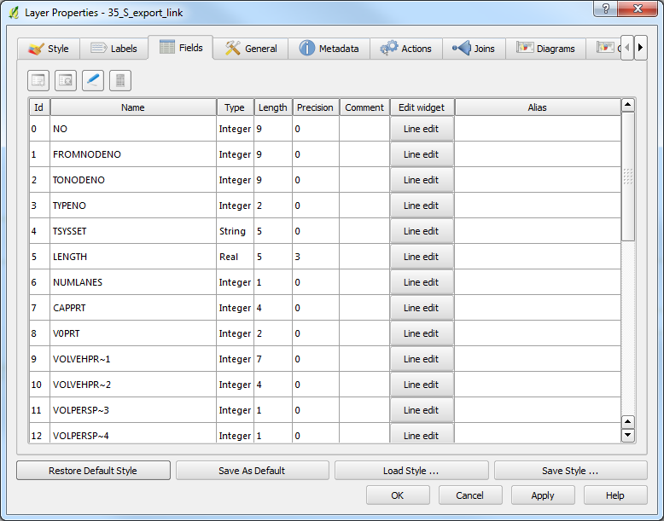

**Figure 11: Link list in Q GIS**

The next section is the zone table. The settings for the zone attributes are similar as for nodes and links, with the only important attribute being zone ID. The correct ID name is read from the zone link list in VISUM, or through the attribute table in GIS software:

|  |  |  |  |  |
| --- | --- | --- | --- | --- |
| section | key | value | allowed_values | required |
| zone | zone_id | NO |  |  |

The sections for the zone centroid and connector conversions are optional, and they need to be defined only if these layers are exported to shapefiles. In this example, the connector and zone centroid layers are exported from VISUM, so we need to define the importing configuration. The corresponding codes are read from the connector and zone lists in VISUM, or through the attribute table in GIS software. The definitions for centroids are name, node ID, and zone (TAZ). The definitions for connectors are zone end, link end, node end, length, number of lanes, hourly capacity, default speed limit, default link type, and direction.

|  |  |  |  |  |
| --- | --- | --- | --- | --- |
| section | key | value | allowed_values | required |
| centroid | name | NAME |  |  |
| centroid | node_id | NO |  |  |
| centroid | TAZ | NO |  |  |

|  |  |  |  |  |
| --- | --- | --- | --- | --- |
| section | key | value | allowed_values | required |
| connector | zone_end | ZONENO |  |  |
| connector | link_end |  |  |  |
| connector | node_end | NODENO |  |  |
| connector | length | LENGTH |  |  |
| connector | number_of_lanes |  |  |  |
| connector | hourly_capacity |  |  |  |
| connector | default_speed_limit | 60 |  |  |
| connector | default_link_type | 10 |  |  |
| connector | direction | DIRECTION |  |  |

The next sections define the final output, control type, and minimum and maximum values for speed limits for signals. These sections can be left as they are in the default file. The control type is defined in a separate CSV configuration file. Once the configuration file is populated and placed in the destination folder, the exported files are ready to be imported in NeXTA.

#### 2) Use NeXTA’s import network tool to convert the network

Starting with a new, empty network project in NeXTA, the conversion process is initiated by selecting the appropriate tool in the Import Menu. Go to File -> Import -> GIS Planning Data Set. A pop-up dialog box will inform the user about the importing configuration and required CSV files. The user can copy the sample CSV files to the destination folder before import. The user also has the option to access the online help document. This step is shown in Figure 12.

|  |  |  |
| --- | --- | --- |
|  |  |  |

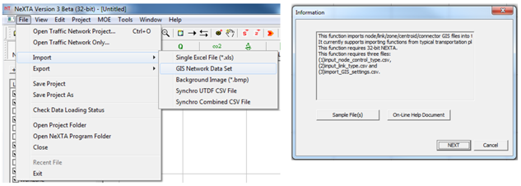**Figure 12: GIS Network Import Menu location in NeXTA**

Press NEXT, navigate to the destination folder, select the import_GIS_settings.csv configuration file created in the previous step, and click Open, as shown in Figure 13. In the next step, NeXTA will display an import window, where the user can review the GIS import settings and make any changes if necessary. The importing window has three tabs, namely Input Node Type, Input Link Type, and GIS Import Settings. These settings should correspond to the defined CSV files. The Edit File in Excel option opens the corresponding CSV file in Excel. There is also an option to fetch the corresponding GIS field names in the case when user cannot find their definition. Selecting Import GIS Data will load the network into NeXTA. The importing window is shown in Figure 14.

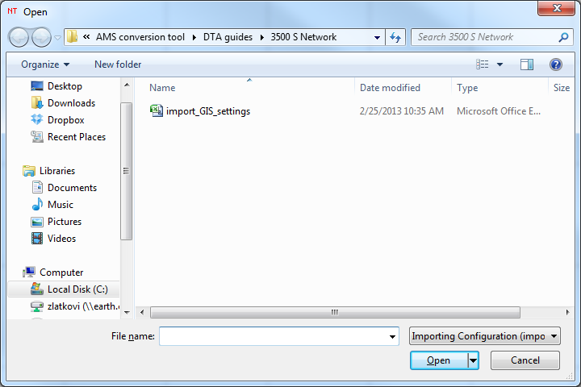

**Figure 13: Opening the import GIS settings configuration file in NeXTA**

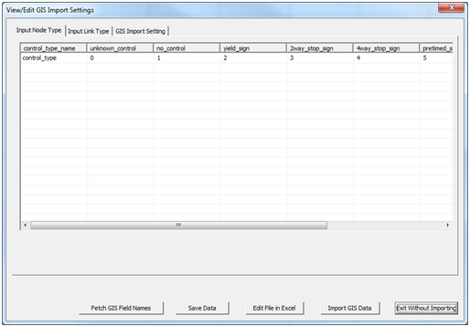

**Figure 14: GIS importing window in NeXTA**

Before importing the network, NeXTA will check the validity of the importing configuration. If there are any mismatches, it will provide a warning about the missing attributes, such as for example the following message:

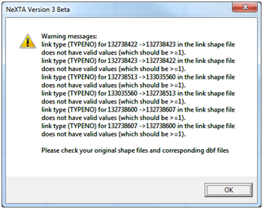

**Figure 15: GIS importing error message**

This message refers to certain links which in VISUM are of Type 0 (unused). This error can be fixed later in the input_link_type.csv, and input_link.csv files. The input_link_type.csv file should be updated with the current link types that exist in VISUM.

After the conversion process is complete, a File Loading Status window opens to display the results of the conversion process. Make sure to note the number of links, nodes, and zones (if any were selected for import) against the number of records in the shapefiles to make sure the process was completed successfully (no missing records). The file loading status for the current example is shown in Figure 16.

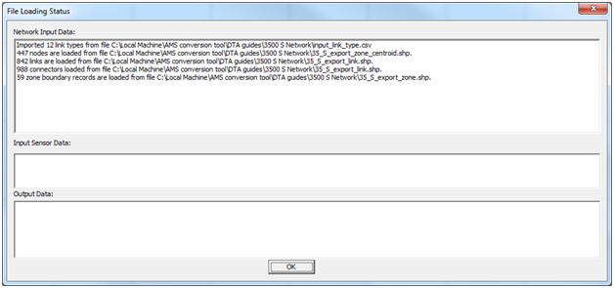

**Figure 16: File loading status window displays import results after completion**

The imported network should look similar to Figure 15 below.

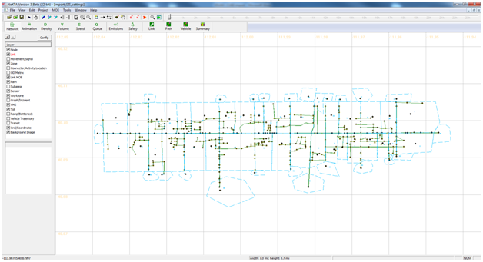

**Figure 16: West Valley City (35 S) sub-network imported into NeXTA/DTALite**

#### 3) Save the new network as a new project file

Finally, save the network as a new Transportation Network Project (*.tnp) file to write the input tables in the project. In NeXTA, go to Menu File Save Project As, navigate to the destination folder, give the name to the project, and press Save. NeXTA will provide information on the main attributes of the new project network. This procedure is given in Figures 16 and 17.

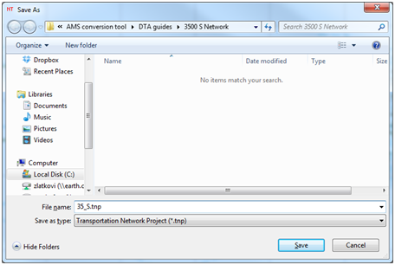

**Figure 16: Saving new NeXTA/DTALite project file**

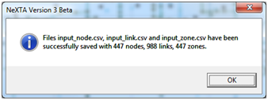

**Figure 17: New project status window**

## Methodology for Importing Cube Networks

Cube is another macroscopic simulation tool widely used by transportation agencies for their regional planning models. A network from Cube can be exported to shapefiles, so the same network can be imported into NeXTA. The exporting process from Cube is similar to VISUM. Please refer to the Cube User’s manual for details on exporting to shapefiles. Also, the importing process into NeXTA is the same as for VISUM. The only adjustments need to be made to the import_GIS_settings.csv file. Here we provide an example for the [South Jordan, UT sub-network](https://drive.google.com/?tab=wo&authuser=0#folders/0Bw8gtHCvOm7WcVBXRmltZGhJcVk).

## Example 2: [South Jordan Sub-Network](https://drive.google.com/?tab=wo&authuser=0#folders/0Bw8gtHCvOm7WcVBXRmltZGhJcVk)

This example provides a guide for importing South Jordan sub-network, originated from Cube, for use in NeXTA/DTALite. The sub-network was obtained from the regional planning model and customized in Cube.

### Step 1: Export network and demand data from Cube

The first step is to create a set of shapefiles describing the network to be imported into NeXTA. This is accomplished using export functions in Cube. At the minimum, layers for nodes and links must be exported. The demand data can be exported from Cube, or demand data available in some other format can be used. In this example, the following layers are exported:

* Node layer: SJ_Node.shp
* Link layer: SJ_Link.shp
* Zone layer: SJ_Zone.shp

### Step 2: Import network from Cube

The second step in the network conversion process is to use NeXTA’s network import tool to convert the shapefiles (created in the previous step) into a network which can be used with NeXTA and DTALite. In order to interpret the database (DBF) files for conversion, a GIS configuration CSV file is used to map field names between the shapefiles and the standard data format used by NeXTA (import_GIS_settings.csv).

The network import process is divided into three steps, same as for importing VISUM networks:

1. Prepare the configuration file for conversion
2. Use NeXTA’s import network tool to convert the network
3. Save the new network as a new project file

#### 1) Prepare the configuration file for conversion

The importing configuration file (import_GIS_settings.csv) is the only step that will be different from importing a VISUM network, due to different attribute definitions. In order to read the attributes correctly, the user is encouraged to use any available GIS software to access layer attribute tables.

In this example, we first define the layer file names and configuration in the configuration file:

|  |  |  |  |  |
| --- | --- | --- | --- | --- |
| section | key | value | allowed_values | required |
| file_name | node | SJ_Node.shp |  | x |
| file_name | link | SJ_Link.shp |  | x |
| file_name | zone | SJ_Zone.shp |  |  |
| file_name | centroid |  |  |  |
| file_name | connector |  |  |  |
| configuration | with_decimal_long_lat | yes | yes;no |  |
| configuration | length_unit | mile | km;mile |  |
| configuration | number_of_lanes_oneway_vs_twoway | oneway | oneway;twoway |  |
| configuration | lane_capacity_vs_link_capacity | lane | lane;link |  |

The next step is to define the node attributes. Opening the node layer shapefile in Quantum GIS provides an easy access to the node attribute table, which we need to read the node attributes correctly. Figure 22 shows node attribute table in Q GIS:

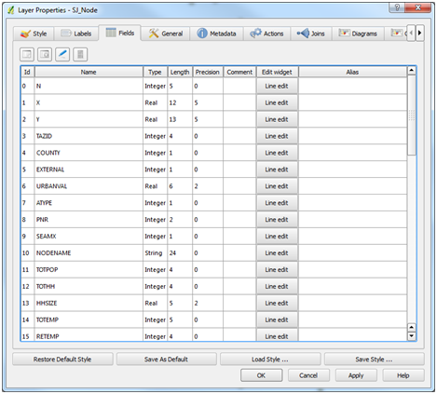

**Figure 22: Node layer attributes exported from Cube for South Jordan sub-network**

Based on these attributes, we update the node table in the configuration file:

|  |  |  |  |  |
| --- | --- | --- | --- | --- |
| section | key | value | allowed_values | required |
| node | node_id | N |  |  |
| node | name | NODENAME |  |  |
| node | TAZ | TAZID |  |  |
| node | control_type |  |  |  |

The next step is defining the link attributes. They can be accessed by opening the layer shapefile in Q GIS as given in Figure 23:

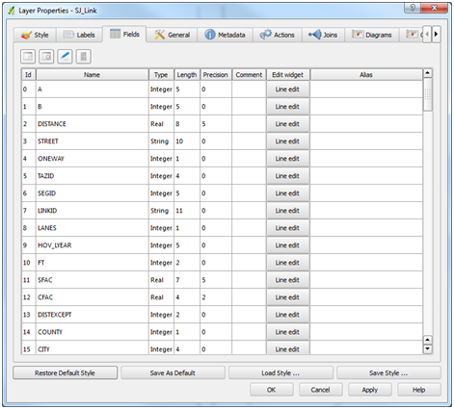

**Figure 23: Link layer attributes exported from Cube for South Jordan sub-network**

We populate the link table in the configuration file according to the given attributes:

|  |  |  |  |  |
| --- | --- | --- | --- | --- |
| section | key | value | allowed_values | required |
| link | from_node_id | A |  |  |
| link | to_node_id | B |  |  |
| link | name | STREET |  |  |
| link | link_id | LINKID |  |  |
| link | link_type |  |  |  |
| link | mode_code |  |  |  |
| link | direction |  |  |  |
| link | length | DISTANCE |  |  |
| link | number_of_lanes | LANES |  |  |
| link | hourly_capacity | CAP1HR1LN |  |  |
| link | speed_limit | SFF |  |  |
| link | r_number_of_lanes |  |  |  |
| link | r_hourly_capacity |  |  |  |
| link | r_speed_limit |  |  |  |
| link | r_link_type |  |  |  |

The last exported layer is the zone layer. We again open it with Q GIS to access its attributes, as shown in Figure 24:

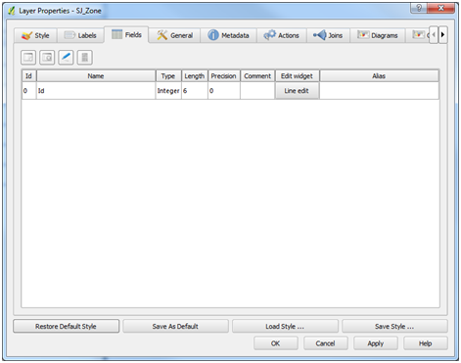

**Figure 24: Zone layer attributes exported from Cube for South Jordan sub-network**

The zone table will have the zone ID field as:

|  |  |  |  |  |
| --- | --- | --- | --- | --- |
| section | key | value | allowed_values | required |
| zone | zone_id | Id |  |  |

The centroid and connector fields will be empty in the configuration table, since we do not have those layers exported from Cube. The “offset_link” can be kept to the default value as “yes”, as well as the values for minimum and maximum speed for signals.

#### 2) Use NeXTA’s import network tool to convert the network

As for the VISUM network, the Cube network can be imported into NeXTA through Menu File GIS Network Data Set. We navigate to the South Jordan sub-network folder and select import_GIS_settings.csv file. This network will now be imported into NeXTA, as shown in Figures 25 and 26:

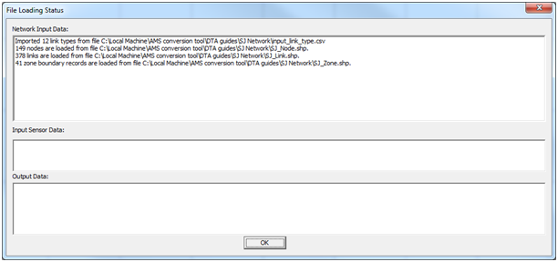

**Figure 25: NeXTA file loading status for South Jordan sub-network**

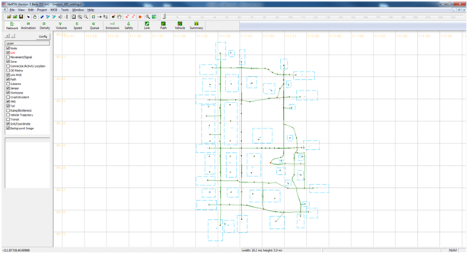

**Figure 26: South Jordan sub-network loaded into NeXTA**

The last step is to save the network as a new network project (File -> Save Project As), and the new network can now be manipulated through NeXTA.

**Extra Steps: Run assignment with DTALite to equilibrium**

### Import demand data from regional travel demand model

The demand matrix from VISUM is exported in Format O, which is a typical 3-column format for zone-to-zone demand. The demand data settings are defined in the input_demand_meta_data.csv file in the project folder. In this CSV file, among other settings, the user defines the scenario to which the demand is applied, the file sequence if there are more than one demand data table/matrix, the format type, number of lines to be skipped, loading multiplier, simulation start and end times, and different demand types. Note that these settings can be accessed and changed directly within NeXTA, through Menu -> Project -> 2. Demand Meta Database. The main settings for the given network are as follows:

|  |  |  |  |  |  |
| --- | --- | --- | --- | --- | --- |
| scenario_no | file_sequence_no | file_name | format fype | number_of_lines_to_be_skipped | loading _multiplier |
| 0 | 1 | 35_S_matrix.mtx | multi_column | 8 | 1 |

The demand matrix exported from VISUM has the format as shown in Figure 20.

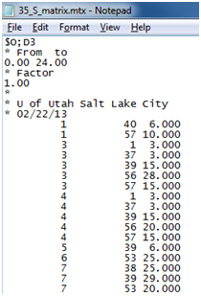

**Figure 27: Demand matrix format**

After all network and demand data are imported, the network is ready for running DTA. Note that any changes can be made in NeXTA through Menu -> Projects. The simulation is run by pressing the Start simulation button located in the toolbar menu. The popup window that appears shows the defined settings, and allows a selection of the traffic flow model, traffic assignment method, the number of iterations, and the demand loading multiplier, as shown in Figure 21. When the selections are made, pressing OK starts the DTA simulation.

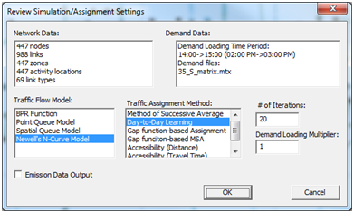

**Figure 28: Simulation/Assignment settings window**